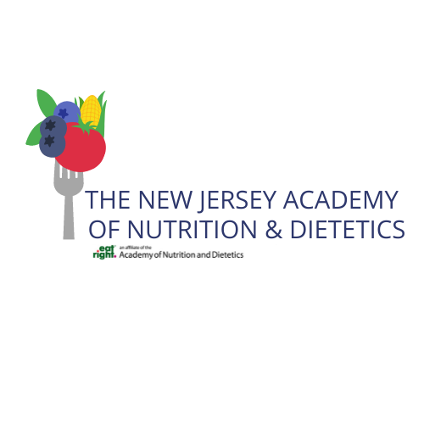

Outstanding Dietetics Student Award
Applications are due by Sunday, March 24, 2024

Award Information Provided by The Academy of Nutrition and Dietetics
The purpose of the Outstanding Dietetics Student Award program is to recognize the emerging leadership and achievement of students in ACEND-accredited dietetics education programs and encourage their participation in the Academy of Nutrition and Dietetics. A student from each type of education program within a state will be selected by each state association (a maximum of six per state).

In addition to publishing the list of outstanding students in the Journal of the Academy of Nutrition and Dietetics, each awardee will receive a congratulatory letter and certificate signed by the president of the Academy of Nutrition and Dietetics.

Criteria for Selection of Outstanding Students
- Member of the Academy of Nutrition and Dietetics. Students must be members by January 1st of the year in which they would receive the award. Students must supply their membership number; membership identification numbers will not be provided to a third party (i.e., educators).
- Student enrolled in ACEND-accredited dietetics education program (CP, DI, DPD, DT, FEM, IDE/FDE).
- Demonstrated academic achievement as documented by letters from program faculty or preceptor.
- Demonstrated leadership and professional potential, e.g., honors, student dietetic association activities, community service activities, etc.

Selection Procedure
- Nominations will be solicited from program faculty or preceptors by the affiliate association.
- Complete responsibility for the selection of outstanding students rests with the state associations. The affiliate award chair, affiliate president, or person designated by the state should coordinate the process. Another state officer or person may be designated to coordinate award information/applications for the state if needed.
- A maximum of one student from each type of dietetics education program within the state may be selected by each state (maximum six). States may choose not to participate or to select fewer than the maximum number. Students may not win ODSA more than one year, even if they are in a different category.
  - Coordinated Program in Dietetics (CPD)
  - Dietetic Internship (DI)
  - Didactic Program in Dietetics (DPD)
  - Future Education Model Graduate Programs (FEM)
  - Dietetic Technician Program (DT)
  - International/Foreign Dietetics Education Programs (IDE/FDE)

Award Recognition
- A certificate of recognition will be sent to the selectees together with a congratulatory letter from the President of the Academy.
- The list of recipients for the year will be published in a fall issue of the Journal of the Academy of Nutrition and Dietetics provided information is submitted to the Academy by May 1st.
- State associations may wish to recognize awardees from their states at state meetings or in state publications.
- Publicity for affiliate recipients should be handled by the affiliate or district public relations chair.

Award recipients will be recognized at the upcoming annual NJAND Annual Meeting. To be considered for this award, the following information must be completed and submitted:
- Submit the following to NJAND Awards Chair, Anisha Chhibber, at anishacanand@gmail.com as Word or PDF document by email:
  - Completed nomination form below. (You will need to download this file to your computer and save it).
  - Letter of Recommendation
  - Resume or curriculum vitae
  - NOTE: all files emailed should begin with candidate’s last name (e.g. “Smith – nomination form”)

- The nominee or a designated person shall provide data as outlined on page 3 (see below).

NOMINATION FORM – OUTSTANDING DIETETICS STUDENT AWARD
CONTACT INFORMATION OF NOMINEE
First and Last Name: first name last name.
AND Number: enter number Program Type: Program Type.

Cell Phone: cell phone Email Address: email address.
Home Address: Street address, City, State, Zip.
Country: Country
Institution/Program: Institution/Program City/State: City/State
Major Field of Study: field of study
Cumulative GPA: GPA Last Semester GPA: GPA
CONTACT INFORMATION FOR INDIVIDUAL/ORGANIZATION MAKING NOMINATION
Name of Person Making Nomination: first name last name.
Title: title.
Cell Phone: cell phone. Email: email address.
Completed nominee information will be accepted until Sunday, March 24, 2024.

Part 2:

Please list your major activities, achievements and honors below that indicate scholarship and leadership:

- Please list your major college activities.

- Please list your major college achievements, honors and awards.

- Please list your community activities.

- Please list your community achievements, honors and awards.

- In under 500 words, please describe why you should receive NJAND’s
Outstanding Dietetics Student Award.

